**EEL 3701C - Digital Logic & Computer Systems**

**Lab Report**

Due one week after regular lab completion.   
Delay penalty: 10% per week, maximum 40%

Greg Bolling

64911960

**Problem Statement:**

For this assignment, we implemented a clock divider which utilized a binary counter in order to create the clock signal. The VHDL code created was able to use the frequency to either slow down or speed up the clock cycle.

A modified and simpler version of a washing machine was also created which considered multiple inputs (temperature, open door, water pressure), in order to output the particular led for a heater. The determination of output settings on the heater was determined by a sequence of standard logic gates.

Finally, a seven-digit display was created, and used binary coded decimal numbers in order to light up particular segments of the display. The outputted decimal numbers one through nine were displayed as output to this program.

**Design:**

The components used for the integrated clock program consisted of inputs A, B and the clock. Both inputs A and B were used for switches 1 and 2 respectively and were used to create an XNOR logic gate. The clock input was connected to the internal clock used from the out of the box circuit and is wired to a third switch. The output is an LED and is connected to the first LED on the circuit board. The reset input is used to reset the LED output and will override the clocks output. This is connected to the input of switch 4. The pros of this design include

The components used for the washing machine program consisted of inputs TemperatureRightLevel, WaterRightLevel, and DoorIsClosed. These inputs each connected to switches one, two and three respectively. The outputs of the program were variables HeaterOn, MotorOn, and WaterValveOpen, and were connected directly to LED outputs one, two and three respectively. The logic gates from this design included a combination of inverters and “and” gates. The benefits of this design allow for safety of the washer machine to not turn on unless all inputs are satisfied. A con in this design is that the logic gates and inputs are too simplistic and minimal to be of any use to a real washing machine and would require more input values and logic gates for use.

The seven-segment display used binary inputs one, two, three and four in order to connect to switches one through four respectively. The outputs used for this display include eight outputs numbered zero through six and are outputted to pins for each segment of the seven-segment display. Binary conversion to decimal was used in order to convert the numbers one through nine to a specific LED light up of the display. The pros about this design choice are that the seven-segment display was very flexible to the change in LED displays for each instance of switch input. A con to this design would be that producing an nth-segment display would require an nth number of output wires for the display, and a more convenient method of efficiency would be required.

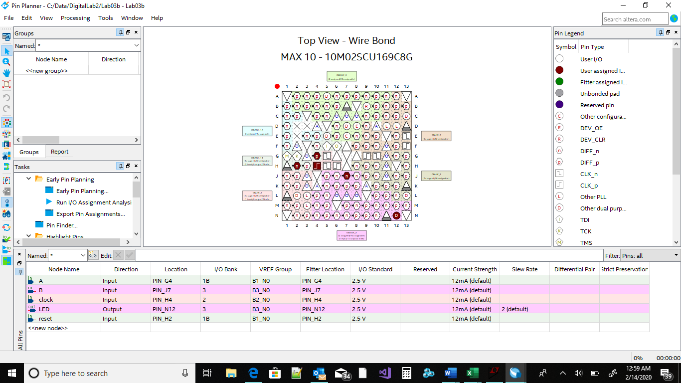

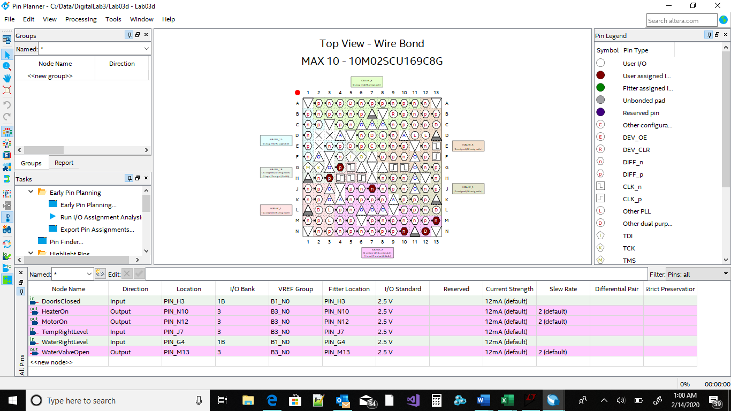

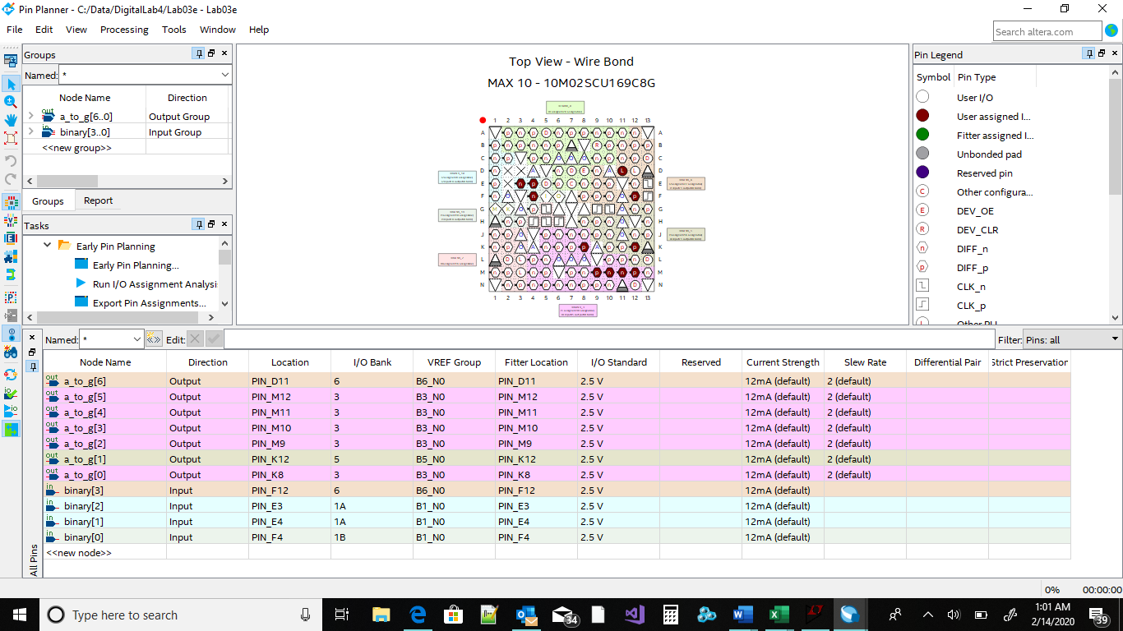

**Implementation:**

The clock divider design consisted of the inputs A, B, reset, and clock, which were all combined into the same logic gate and connected to a singular LED output state. The inputs A and B used an XOR gate (chosen at the discretion of the programmer). The clock input was then connected through the use of an AND gate to A and B. Reset was inherently connected to the clock through the use of particular if else statements. The LED output displayed produced a one if the clock was on, or either the input of A or input of B produced a one, but not both simultaneously. The LED was off if the reset produced a one, if the clock event was a zero, or if inputs A and B were both on simultaneously. The input was computed using switches. The frequency used for the clock divider was 3d08ff in hexadecimal form.

The washing machine design was implemented using a series of logic gates and inputs. The first logic gate required that the water to be the right level, the door to be closed, and the right temperature level to be inverted so that the heater could be on. In the second logic gate, the door needed to be closed and the right water level needed to be inverted for the water valve to be open. The final logic gate required that the door had to be closed, the temperature had to be the right level, and the water had to be the right level in order for the motor to be turned on. Each of the LED displays represents the state of the motor, water valve, and heater.

The seven-segment display was designed with nine inputs represented by nine different outputs, each with a different display combination of LED’s which will light up on demand. The conversion from a binary to decimal numbers was implemented so that each particular four-digit binary number would be transferred to a seven-segment display with each output shown as a zero or one. This zero or one corresponded to each led display which would either be turned on or off.

**Testing:**

Each design was tested by plugging in the wires to the desired inputs and outputs and testing each switch to see if the LED outputs matched with the truth tables computed from the logic gates in the VHDL code. If the LED for the clock program was on indefinitely, this meant that the frequency of the clock had not changed in order to slow the time period of each individual clock cycle. Likewise, the Motor, Heater, and Water Valve each hade to produce an LED light for each of the correct inputs coming from the switches (originally programmed from VHDL). The seven-segment display also had to produce all segments correctly for each output that was inputted from binary values.

Not everything in the design worked initially as expected. The seven-segment display was not producing the correct LED outputs at first due to the fact that the wires were not connected to each segment correctly and were mismatched out of place. This caused the output display to fail to produce one LED crucial to the display number eight.

The first clock design also was unable to produce output of any form due to the fact that the wire for the clock was not inputted into the out of the box circuit clock input and was instead inserted into 5 voltage VCC. This effected the designed and caused no LED to turn on until the wire was corrected.

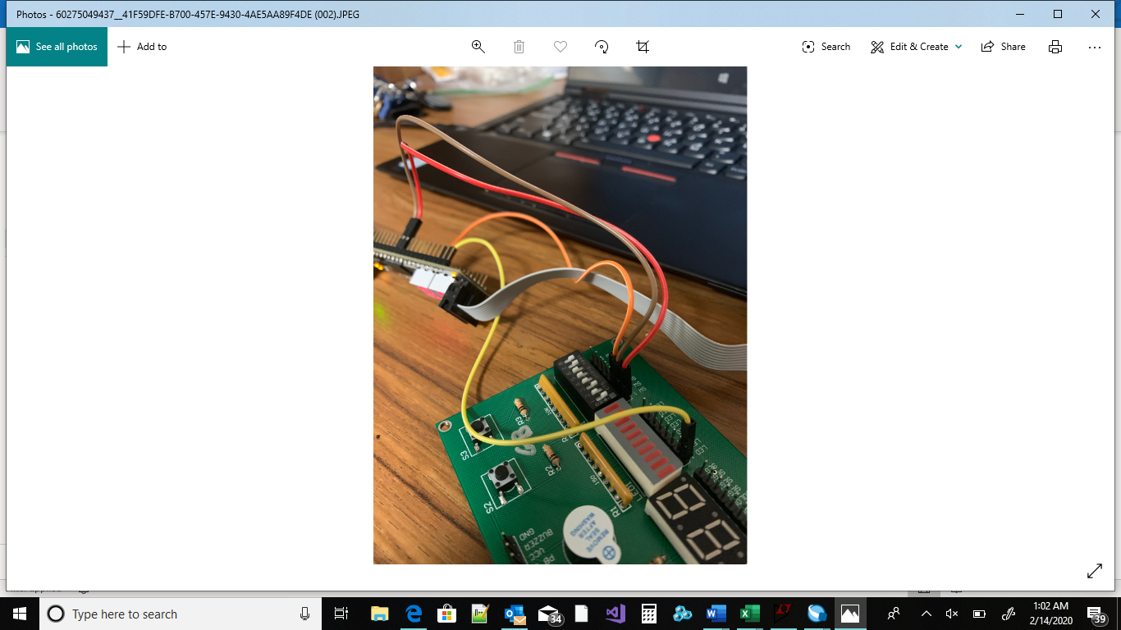

**Conclusions:**

The three designs implemented in this lab allowed students to learn how to integrate clocks and registers with regular circuit design and displays. Students also learned more practice on how to create logic gates to produce particular outputs in the form of real application variables such as temperature or water level. The third design presented to students what a seven-segment display is, and how it can be implemented through the use of a binary coded decimal form. Each design process required different input and output wires to be connected to certain switches, LED’s and segment display inputs in order for each design to respond correctly. In order to improve on correcting the display and clock design mistakes in the future, I plan on double checking the wires to make sure that each wire corresponds directly with the corresponding input/output and is not switched around with another wire of similar use.